In banner few pic as per our work

About Us—we shall add a small video apart from text
Inception Training & Consulting is an interpersonal skill development firm where we provide world class training and consultancy to each student or individual who wants to develop and sharpen soft skills and life skills. We also facilitate instructor led training programmes for employees to enhance their interpersonal skills. The programs are designed with the best practices of experiential learning methodologies keeping in mind to bring the attitudinal shift in the minds of everyone to attain the level of self-mastery.

Note: We shall write more, for that one dedicated page need to design, where we shall put team and director details, so READ MORE button have to add.

Services
- Online & Onsite Training.
- Student Coaching.
- Educational Consultancy.
- Employability skills enhancement training
- Public Workshop
- Outbound Training
- Personality Assessment.

All services should have brief introduction and dedicated page with detail explanation with
REQUEST NOW button, where they can filled their requirements .

SPECIAL PROGRAM -
We have a signature program called EVLOVE
- E- EFFICIENCY TO BE SCALED UP.
- V- TO BRING VIVID CHANGE
- O-WITH OPENNESS
- L-AND LIKEABLE
- V-BE VORACIOUS
- E-TO BE EXCELLENT

FOR STUDENT

EVOLVE- Basic | EVOLVE- Intermediate | EVOLVE- Advance
7 Session  - Basics training on the essential Soft skills.  ***Will mention all skills list | 15-session  - In-depth training on the essential Soft skills and Life Skills.  ***Will mention all skills list | 1-year --- Upto Class 10  - 1 to 1 coaching on essential soft skills and life skills  - Academic and personality growth tracking  ***Will mention all skills list

FOR JOB ASPIRANT---
EVOLVE- Basic | EVOLVE- Intermediate
10 Session  - Basics training on the essential employability skills.  ***Will mention all skills list | 20-session  - In-depth training on the essential Employability skills  ***Will mention all skills list

All the sessions are designed to develop interpersonal skills or soft skills in an individual.
These skills are also known as generic life skills which are cluster of personal qualities, habits, attitudes, and social graces that make an individual successful in any field or in life.
These skills make a person confident enough. Moreover, there are advantages like self-satisfaction, respect in society, influence in groups or teams, receive appreciation and recognition from others.
Moving little bit deeper, let's see the most important personal attributes that make a person successful in any domain or more specifically to develop leadership qualities.

Interpersonal skills
Integrity
Honesty
Dedication
Manners & Etiquette
Ethics
Pride in work
Persistence
Good listener

In layman, we develop these traits in individuals to reach the level of self-mastery.

Ongoing Session booking

- Adaptability to learning
- Creative thinking
- Master your habits

UPCOMING SESSION AT SCHOOL OR SPECIFIC LOCATION :
We have to add a special session section where we can add upcoming event details so that students can book directly.

Example: We have a session on Christ Jyoti Nagaon on January,
Have to add a Special Free counselling session Button
Topic In drop down menu
Example: 1. Study/Career related
2.Program related
3. Any other concern

NEWS AND EVENTS
This section we shall add event photo and all

Our Clients
Like below. But we shall add schools, since most of the Clients will be school
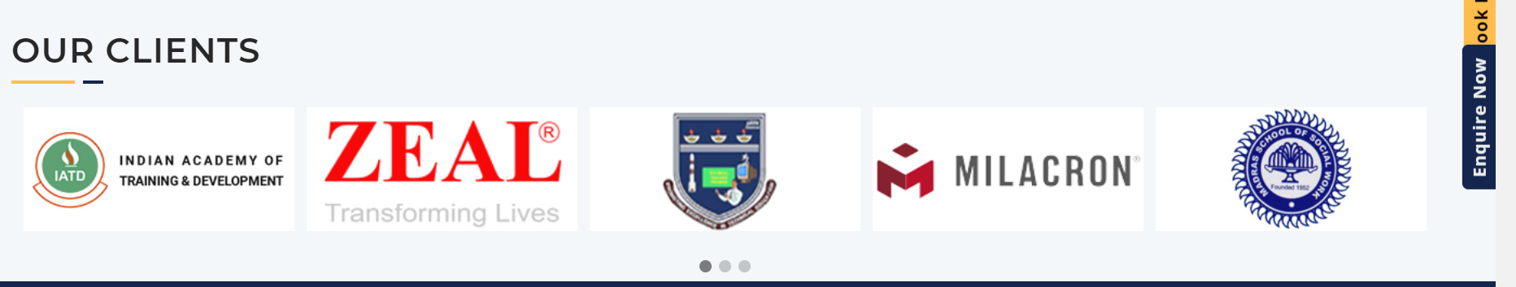

Testimonials

Blog: In a new page, no need to add in home page
Enquiry now button, which will include looking for dropdown menu , Booking event button

Contact us section

Our Youtube channel video and facebook page view should present in home page.

